Title: The impact of business size and industry sector on the use of technologies within UK businesses: ecommerce websites in retail sector as an example.
Full name: OULBACHA ilyas
STUDENT ID: C7282143
Submitted in partial fulfilment of
the requirements of Leeds Beckett University
for the Degree of
MSc IT

School of Built Environment, Engineering and Computing
Leeds Beckett University
January, 2022

Contents
I- Abstract: 2
II- Introduction: 3
1. context of research: 3
2. rationale : 3
3. Aim and objectives: 5
III. Literature review: 6
1. The outcomes of ICT (information and communication technologies): 6
2. Theoretical framework of ICT adoption within organizational contexts: 7
a. Innovation diffusion theory: 7
b. TOE Framework: 8
3. The impact of ICT adoption on UK’s firms’ ecommerce sales: 11
IV. Methodology, analysis, and visualization 11
1. Descriptive statistics about websites use and ecommerce sales in the UK. 11
2. Descriptive statistics about ecommerce sales in the UK: 14
3. Chi-square: to determine the impact of different organizational variables on the use of ICT within UK businesses: 17
4. A forecasting model of ecommerce sales of UK businesses: Retail ecommerce sales as an example. 20

Abstract:

Digital transformation is the latest revolution that humanity is living today. All the society components are concerned: individuals, governments, and businesses as well. In this project, we study one of the most elementary aspects of digital transformation: technologies adoption within businesses.
Our study is about exploring and confirming in the same time: exploring the literature review to discover which the most considered factors considered when it comes to study the adoption of a technology. Both The innovation theory and TOE(Technology, Organization, Environment) framework have been used in this project to provide a strong scientific background of our analysis. A dataset was selected from the National Office of Statistics, then organized and preprocessed for the purpose of a very reliable analysis and visualization.
Our aim is to investigate how the variables (business size and industry sector ) impact the use of websites within UK businesses. Our aim is then divided into 3 main objectives which we used 3 main data analysis techniques.
Our Descriptive statistics analysis shows that there is an inequality of both use of websites and outcomes gained from ecommerce among different businesses sizes within the Uk. The inferential statistics confirm, based on a chi-square test, the dependence of the proportion of UK businesses using websites with industry sector and business size.
An ARIMA model is generated to forecast the upcoming two years retail ectomeres sales
Evolution. However, while the disparities in terms of websites use persist, the largest business will always be the monopoly of ecommerce sales.

Introduction:

context of research:
In the current economic context surrounded by technological progress, and increasingly becoming complex, organizations find themselves in the extreme obligation to follow this progress, whether at the economic level or the technological one. In parallel, several countries around the world have implemented digital transformation strategies, which include both dematerialization of services and support to use and adopt them , offering citizens and businesses more convenience and flexibility(Nadkarni,Prügl,2021).

rationale :
Technology advocators suggest that once technologies are fully diffused in economy, then economic productivity will take a new wave of rising (Brynjolfsson et al,2018). Productivity gain is known to be low in the UK’s economy compared to both its international competitors and its history(Valero and Van Reenen,2009). This could be supported by the fact that UK’s firms technologies adoption remains low; it is ranked the 31st worldwide, and only 16 in Europe(World Economic Forum’s World Competitiveness report,2019). However, this trend seems to be changed during the pandemic; both SME and large firms were engaged with using new technologies as a response to deal with disruption in their business models; using video conferencing and software solutions to work remotely, using websites and mobile applications to receive their customers online orders when the instore shopping was restricted (Valero and Van Reenen,2021). However, the covid-pandemic could not be the only acceleration behind this trend; (Hall,2009) suggests that the firm’s investment in innovations is purely affected by the economic downturn, that could be either financial or any other crisis; firms are most likely to adopt new technologies when they both have sufficient resources and believe in the future economic prosperity. Hence technology adoption factors within an organizational context could be, but not limited to, economic, social, and financial factors.
Figure 1: Enterprises with high levels of digital intensity, by size (2019)(Valero and Van Reenen,202)
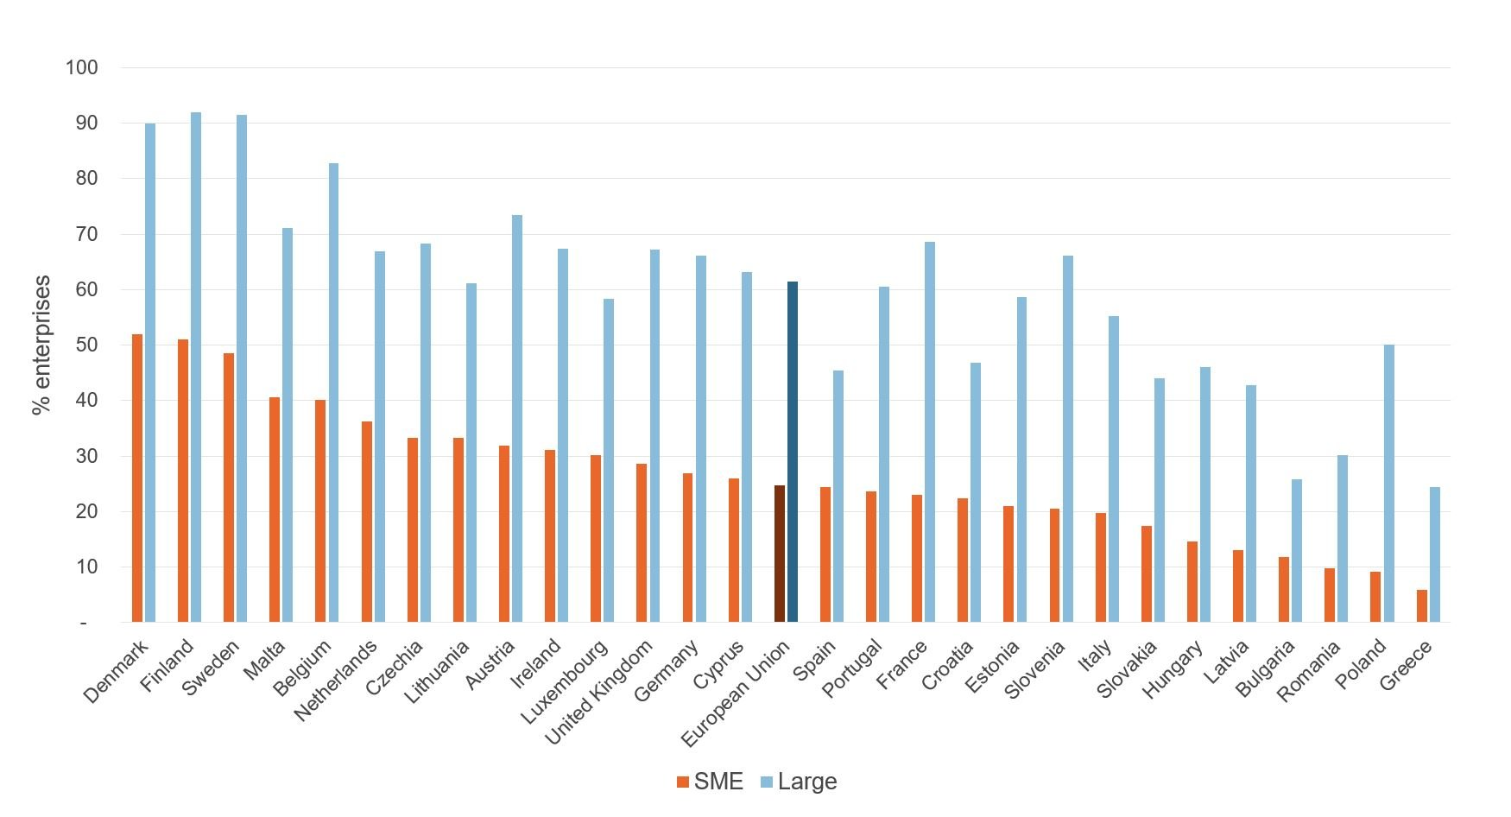

Aim and objectives:

The aim of this project is to investigate the ICT adoption within UK’s firm’s context. The study will not be limited to the covid-19 pandemic nor its impact as we believe that the pandemic is not over yet, which may be challenging int terms of data collection and data accuracy. To reach our aim, we set different but concise objectives to achieve by the end of this project:
  - To explore the literature review about ICT adoption within businesses.
  - To describe the situation of ecommerce and websites use within UK’s businesses.
  - To determine different factors explaining businesses adoption of ICT, mainly websites.
  - To generate a forecasting model for retail ecommerce sales within the Uk.
To achieve these objectives, our project is structured as following: First, a literature review to generate hypothesis on ICT adoption within organizations, followed by an analysis of a dataset on UK’s firms use of ICT and ecommerce activity, and finally a discussion of our findings based on the literature hypothesis. We aim that our findings will both extend knowledge on literature review and improve businesses and governments decision making on adopting ICT.

Literature review:

The outcomes of ICT (information and communication technologies):
Although some restrict it to simple innovations facilitating daily life, the digital revolution is a decisive stage in the history of human societies. Several studies and analyzes, notably that of Kondratiev, have treated it as the most recent of the major revolutions of humanity; namely the British Industrial Revolution, the Railways Age, the Age of Heavy Engineering and Electrification, the Age of Petroleum and Automation, and finally the Age of Information Technology and communication. Digital transformation is defined as “The changes associated with the application of digital technologies in all aspects of human society" (Stolteman and Fors, 2004, p.689). It concerns at the same time individuals, businesses, and governments as well in; insofar as it represents more opportunities than threats.
The gains of digital transformation have been studied by several studies; the most recent one is the Mckinsey report; according to a study carried out in 2012, it was shown that the contribution of the internet to GDP is estimated at 3.4% in the 13 countries studied (United States, France, Germany, the BRICS countries, etc.). However, this gain may not be equally distributed around the world as not all the countries have the same economic level; in Africa, the Word Economic Forum highlighted the weaknesses, but also the development potential of a digital society.

The challenges of digital transformation differ from one actor to another. As companies grapple with issues of business model change, customer experience improvement, and value creation, governments are concerned with questions related to individual freedoms, the transparency of public services, the regulatory power of the government... etc. In the context of the Covid-19 health crisis that shook the world in 2020, the subject of digital transformation has taken off and has become a topical subject for all organizations. Technologies have a decisive role on saving peoples’ lives and help business keep their business models alive (Sanfilippo et al.,2020).

Theoretical framework of ICT adoption within organizational contexts:

Innovation diffusion theory:
The theory of innovation was proposed in 1962 by Everett Rogers and developed at the organizational level by Zaltman, Duncan, and Holbeck in 1973. Its aim is to explain how a technological innovation evolves from its stage of the invention to the stage of extended use. Rogers considers the adoption or diffusion of innovation to be determined by factors related to the technological innovation itself, including relative advantage and compatibility. The other two factors (cost and safety) are judged, according to our readings also determining.

- The relative advantage:
Is defined as the capacity of innovation to serve more businesses and individuals as well as reduce costs (Currie, 2004). Using the various technological tools of digital strategy, companies will be able to communicate effectively with their potential customers and improve their commitment to their loyal customers. Process automation ensures both improved works for users and reduced process costs for both the company and its customers.
- Compatibility:
The extent to which the innovation is compatible with an organization's procedures (Cooper & Zmud, 1990). The classic business focuses on human interaction with customers and gives rise to a simultaneous exchange of non computerized data. Beyond the classic debate on who should adapt to the other: organizational procedures or technological innovation, digital strategy is judged on the ability to translate or even improve a company's procedures.
- Cost:
The expenses necessary for the implementation of technology and the dedicated efforts to restructure an organization or regenerate its procedures (Chircu & Kauffman, 2000). The implementation of a digital strategy will generate infrastructure, training, and user support costs (Tornatzky & Klein, 1982).
- Security:
It refers both to the importance given by the organization to the security of data that is the subject of an online transaction and the requirement of companies and individuals to protect their information (Awan, 2008). Data protection and the confidentiality of user information is critical (Belanger, France, and Janine S. Hiller, 2008). To these technological characteristics are added contextual characteristics. These characteristics find their foundations in the theory of contingency. According to this theory, there is no better way to make decisions, organize or bring about change; all depend on the organizational, technological, and environmental factors of the organization.

TOE Framework:
- Technological competence:
It has two dimensions: IT infrastructure and Internet competence (Zhu et al, 2003; Zhu and Kraemer 2005) [7] [10];
• IT infrastructure: The network of technologies installed by a company for the implementation of a digital strategy.
• Internet skills: The abilities of employees to use Internet based technologies. While it has been claimed that IT infrastructure is a central part of combining information and knowledge fusion in employment online, however, technology alone is not the only prerequisite for implementing a digital business strategy; Adequate resources, substantial infrastructure, management support, efficient IT staff, and essential IT preparation and support are required to ensure a successful implementation of a digital business strategy.
Hypothesis 5: Technological competence has a positive impact on a technology adoption within a business.
- The size of the organization:
It refers to the number of employees in the organization. The size of the organization is one of the most studied factors in innovations (Damanpour 1992). Size represents different aspects such as budget, organizational structure and flexibility of decision making. The larger the workforce of the organization, the more it needs more resources, a complicated structure and decision making becomes less flexible. Organizational factors provide a set of structures that can restrict or facilitate the use of e-business (Tornatzky & Fleischer, 1990; Fletcher & Wright, 1997). The size of the organization or the size of the company is one of the most studied organizational factors in the literature on innovation (Damanpour (1992) for a meta-analysis). Since size represents several important aspects of an organization such as lack of resources, organizational structure and flexibility of decision making, it is a critical organizational factor to influence the use of IT (Rogers,1995).
Hypothesis 6: The business size has a positive impact on technology adoption within businesses.
- Rules and regulations:
They refer to legislation concerning electronic signatures, data protection, access rights, etc. Heeks considers that regulations are regularly required on all activities, from upstream to the offer of the service . Especially since the adoption of information technologies can be carried out in the private sector generally by motivations of optimization and search for opportunities, the rules and regulations become necessary so that the digital strategy does not deviate from its ethical responsibilities. Thus, the rules and regulations, although they can play an incentive role for the adoption of a digital strategy, they represent heavy obligations to assume and procedures of use to follow. (Liang et al) considered that rules and regulations are effective models that guide individual values and attitudes in the affairs of daily life. These rules could be extended to put an end to cultural objections, which may constrain the implementation of a digital strategy within a company.

- Organizational Culture:
These are generally the values and beliefs of a culture of individuals within a social unit. It also refers to the collective consciousness, transmitted behaviors, social institutions, common opinions… The culture of an organization can, among other things, be an obstacle to organizational changes and the adoption of any technological innovation. Some previous studies have been done with the aim of exploring the influence of organizational culture on the use of new technologies, indicating that culture is predictive of the use of organizational technologies. The results indicate that organizational culture is an important element in the development of absorptive capacity, and the influence of the latter in the use of new technologies.
Hypothesis 8: Organizational culture has positive impact on technology use within a business.

The impact of ICT adoption on UK’s firms’ ecommerce sales:
In the early stages of new technologies use, the impact may focus on how often(intensity) a technology is used. However, this approach may not be a very reliable one, as there is no equivalent distribution of technologies use over the world or even within the same economic area; some still at the early stage of implementing infrastructures, others had reached a high level of technology use; in this case the intensity of using technologies wouldn’t be a valid measurement of ecommerce activity. Thus, the analysis would be focused on the outcomes of ICT adoption, like sales, transactions, data generated…etc, rather than a simple action of using or intensity of using technologies.

IV. Methodology, analysis, and visualization
.

Descriptive statistics about websites use and ecommerce sales in the UK.
- Websites use:
The descriptive statistics about the adoption and the use of websites within UK businesses includes both the proportion of businesses using websites and how this proportion varies by business size and industry sector.
Figure 1.2 shows the evolution of UK businesses proportion using websites, regardless of business size and sector ,during the period 2015/2019. It is found that this proportion has jumped from 50,1% in 2015 to 45,2% in 2019, with an average decrease of 1.2 points each year(Figure 1.1).
Figure 1.1: Proportion of UK businesses using websites during the period 2015/2019.

Figure 1.2: Evolution of UK businesses using websites during the period 2015/2019.
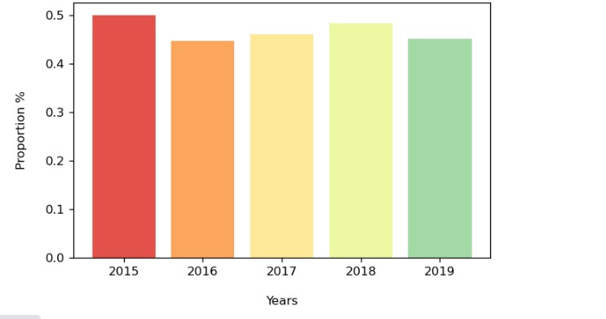
In 2019, the mean proportion of UK businesses, all sizes included, using a website is 81.4%. A standard deviation of 0.23 evidence that there are no such big disparities between almost all the business sizes when it comes to the proportion using websites. However, this proportion within the business size 0 to 9 employees is only 41.1%, which far below the mean. Therefore, while very large businesses (1000 employees or more) show a high level of using websites, very small businesses (less than 9 employees) witness a low level of adopting and using websites. Hence, a deeper analysis is required to verify whether there is any dependence between the business size and the use of websites and what are the other factors that could explain the low level of using websites within very small businesses.
Figure 2.1: UK businesses proportion, by size, using a website in 2019.
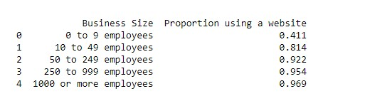
Figure 2.2: Share, by business size, of UK businesses using websites in 2019.
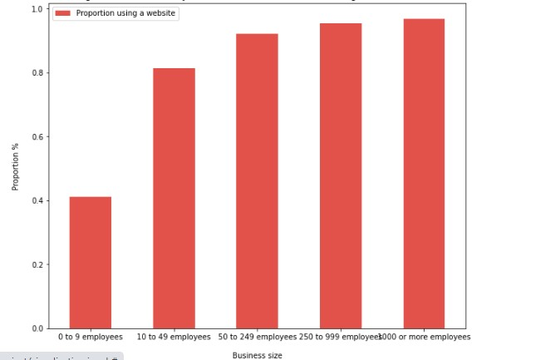
Figure 2.3: Descriptive statistics of the proportion of UK businesses using websites in 2019.
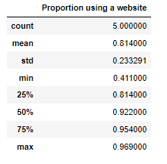

Descriptive statistics about ecommerce sales in the UK:
The analysis of UK businesses ecommerce sales implies a comparison of the main ecommerce sale types (website sales and EDI sales), an analysis of website sales evolution over time and its variation between business sizes.
According to Figure 13.2, the difference between sales over websites and sales over EDI is remarkably insignificant. The two types of sales are growing constantly during the period 2015/2019. However, a slight increase of websites sales is observed in the last 3 years(2017/2019).

Figure 13.1: UK businesses ecommerce sales during the period 2015/2019(in billion £)

Figure 13.2: Evolution of UK businesses ecommerce sales during the period 2015/2019(in billion £).

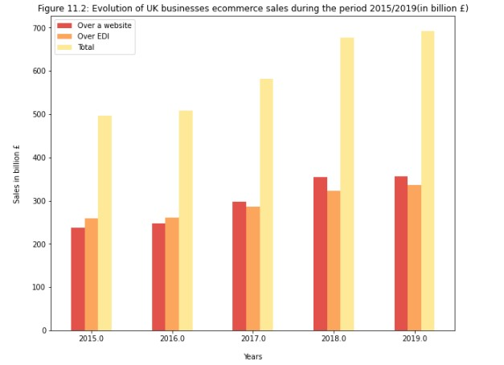
In 2019, the total ecommerce sales of the UK businesses has reached a volume of 6.93 billion $.The figure 14.2 show that more than 50% of total ecommerce sales is credited to large businesses(1000 employees or more).The average ecommerce sales of all UK businesses In 2019 is 1.386 billion £.All the businesses with 249 employees or less are below the mean. The standard deviation is significantly higher, which witnesses of high level disparities in terms of ecommerce sales share between UK businesses of different sizes.

Figure 14.1: UK businesses' ecommerce sales, by size, in 2019(in billion £)

Figure 14.2: Total UK businesses ecommerce sales, by business size, in 2019(in billion $).

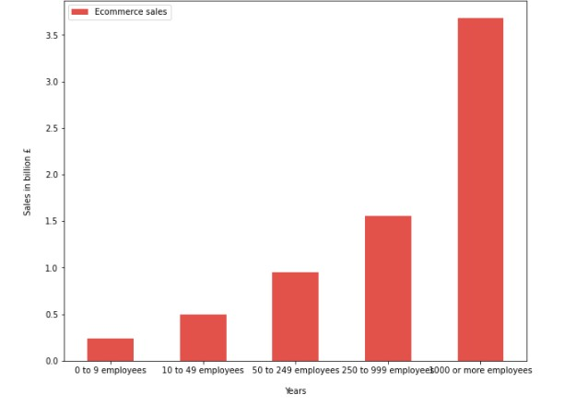
Figure 14.3: Descriptive statistics of UK businesses ecommerce sales in 2019
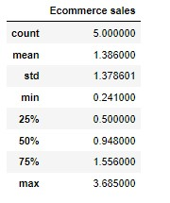

Chi-square: to determine the impact of different organizational variables on the use of ICT within UK businesses:

Chi-square is a non-parametric test. There are two types of Chi-square tests: Chi-square goodness of fit and Chi-square test of independence.

Chi-square goodness of fit is used to evaluate the statistical difference between the expected and observed values of a categorical variable.

To use chi-square goodness of fit test, the following steps should be fulfilled:
- Determine the independent variable(a) and dependent variable(b).
- set the hypothesis:
H0: there is no statistically significant difference between the observed and expected values.
H1: there is a statistically significant difference between the observed and expected values.

- Calculate the frequencies of (how many times b is observed on a).
- Set the expected values; the expected frequencies are calculated based on an equally distributed frequencies assumption.
- Set the confidence level: which in our case is 98%, and alpha=0.02
- Calculate the degrees freedom, which is equal to (Number of outcomes)-1.
- Set the critical value based on the degree freedom and alpha.
- calculate the Chi-square, using the formula: X2=…
- Determine whether p-value is inferior or superior to Alpha based on the Chi-square value.
- Reject or accept the null hypothesis based on the p-value:
- Null hypothesis is rejected is p<alpha.
- Null hypothesis is accepted if p>=alpha.

Our data set contains only the proportion, by business size, of UK businesses using different technologies. To conduct Chi-square test we need to generate a new row for those which don’t use technologies. The new row can be generated by subtracting the proportion of those using technologies from 100%, since there are only two probabilities for the variable “use a technology”: it’s either use or don’t use.

a. The dependence between business size and the proportion of businesses using websites.

- Hypothesis:
The dependence between business size and the proportion of businesses using websites is verified based on the following hypothesis:
H0: There is no statistically significant dependence between business size and the proportion of businesses using websites.
H1: There is a statically significant dependence between business size and proportion of businesses using websites

- Test results:
Figure 19.1: Business size and website use crosstab

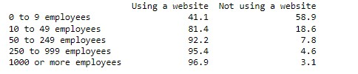
Figure 19.2: Chi-square test results
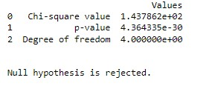

The results of Chi-square tests shows that p-value<0.02, therefore we reject the null hypothesis. The alternative hypothesis is accepted; There is a statistically significant difference between expected and observed proportions of UK businesses using websites. Hence, the business size and use of websites are dependent.

- The dependence between industry sector and the proportion of businesses using websites:
- Hypothesis:
The dependence between industry sector and proportion of businesses using of websites is verified based on the following hypothesis:
H0: There is no statistically significant dependence between the industry sector and the proportion of businesses using websites.
H1: There is a statically significant dependence between the industry sector and the proportion of businesses using websites.
- Test results:
Figure 27.1: Industry sector and websites use crosstab
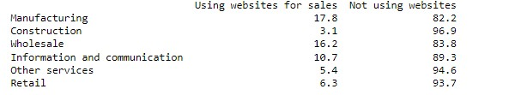
Figure 27.2: Chi-square test results
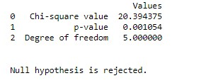
The results of Chi-square tests shows that p-value<0.02, therefore we reject the null hypothesis. The alternative hypothesis is accepted; There is a statistically significant difference between expected and observed proportions of UK businesses using websites. Hence, the business size and use of websites are dependent.

A forecasting model of ecommerce sales of UK businesses: Retail ecommerce sales as an example.

Time series is a set of observations taken at a specified times usually at equal intervals. It is used, not only to extract meaningful statistics about how a variable values change over time, but also to predict the future values based on observed ones.
There are different types of time series: Trend, seasonality, irregularity, cyclic. Each of them has its own characteristics and specific models to analyse them.
For example, if a time series is seasonal, a model called SARIMA is used, instead of ARIMA.
ARIMA (Autoregressive Integrated Moving Average) model is a forecasting model built on the correlation between the previous and current values. It is a combination of the tow models:
- AR(Autoregressive) : predicts the Yt based on the previous values of Y.And;
- MA(Moving Average): predicts the forecast errors based on the lagged forecasting errors.
Because ARIMA model relies heavily on the linear regression, it is compulsory that the time series is stationary.
Therefore, to create an ARIMA model, we need to find 3 parameters:
- Autoregressive lags(P): The number of lags of Y that the model will use as predictors.
- Moving average(q): The number of lagged forecast errors that should be included in the model.
- Order of differentiation(d): Is the number of lags needed before the stationarity is achieved. This number should be minimized.
A test of stationarity is conducted before model fitting. In case the stationarity is not verified, we conduct a differencing (minimizing d) method till the stationarity is achieved(d=0) or nearly achieved.
To test the stationarity, the Augmented Dickey Fuller test is used, which has the following hypothesis:
H0: The time series is not stationary
H1: The time series is significantly stationary.
In a confidence level of 95%, the null hypothesis is rejected if p-value<0.05
- Retail ecommerce sales forecasting model:
Figure 28: Retail ecommerce sales monthly evolution(in percentage) during the period 2013/2021.

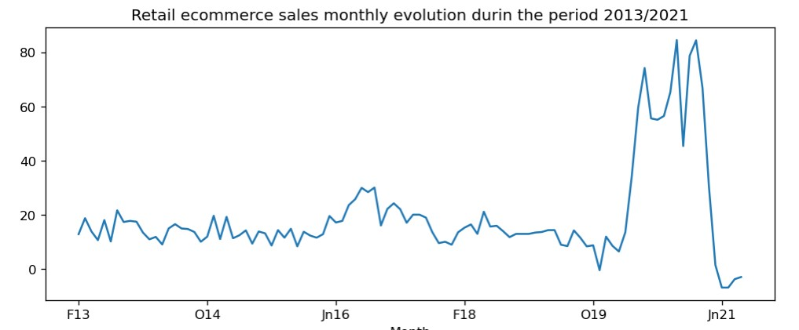
Figure 28.2: Augmented Dickey Fuller test results:

The Augmented Dickey Fuller test results shows that is p-value=0.192. In a confidence level of 95%, Alpha=0.05,which largely inferior to p-value. Therefore, the null hypothesis cannot be rejected. Hence, the time series is not stationary.
- ARIMA model fitting:
  - Calculating the parameters: p, d, q
Figure 29: Original series and 1st differencing autocorrelations:
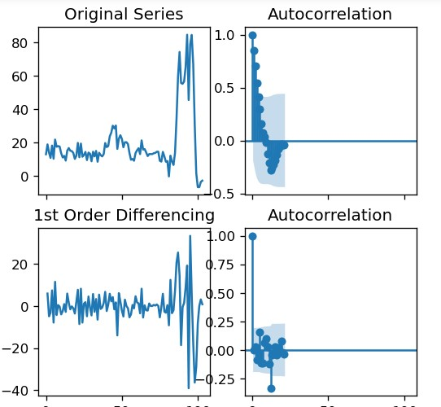
Figure 30: 1st differencing partial autocorrelation
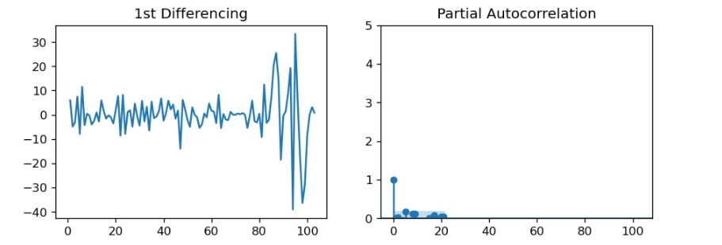
Figure 31: ARIMA model results(p,d and q):

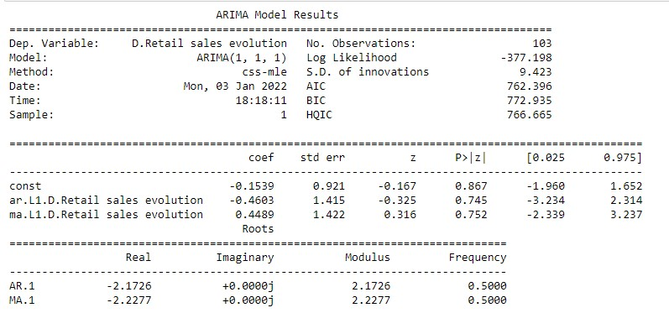
  - Fitting the model:
Figure 33: Fitting the model of Retail ecommerce monthly evolution.

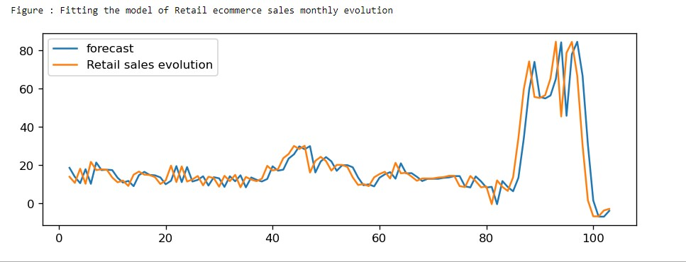
Figure 32: Residuals errors.
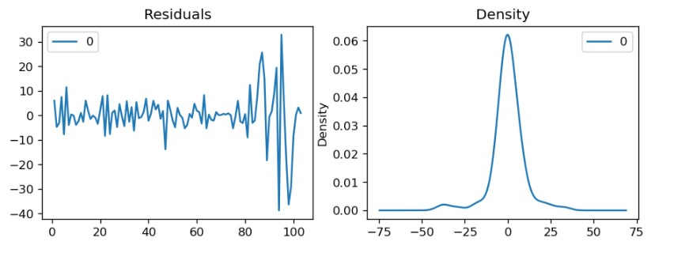
  - Testing the model:
Figure 34: Training and testing Retail ecommerce sales forecasting model.

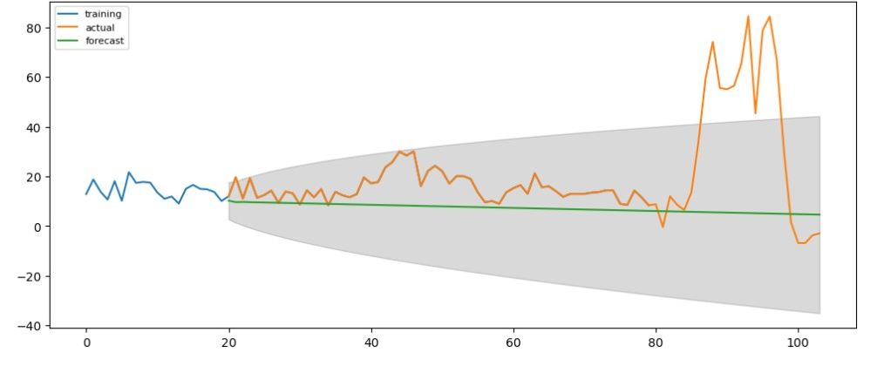
Figure 35 : Forecasting retail ecommerce monthly evolution in the next coming 2 years:

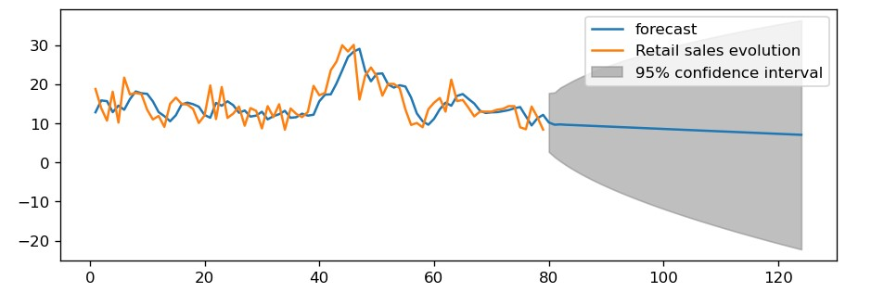

- Discussing the findings:
The descriptive statistics shows that there is a low level of websites using within UK very small businesses, while the proportion of businesses using website nearly reaches its limit within large businesses. The Chi-square test evidenced that the dependence between business size and the proportion of businesses using websites is statistically significant. Such results confirm our literature review findings that stipulate, based on the TOE framework, that business size has an impact on the adoption of technologies. According to this theory, large businesses are more likely the ones who quickly adopt and use a technology. The more a business is large, the more it has the ability and willingness to implement new technologies within its processes. According to the Innovation Diffusion theory, more explanation could be added to explain the low level of websites use within UK businesses; The theory argues that the technology’s characteristics, as relative advantage, and cost of the technology, are decisive factors of its use. Therefore, small businesses may find using websites relative advantage insignificant compared to its cost. However, the comparisons of ecommerce sales of all the businesses reveals that small businesses participation in ecommerce sales is very low, either over websites or EDI. only very large businesses are taking advantage of the opportunities that ecommerce enables.
The second organizational factor that found to have an impact of the proportion of UK businesses proportion using websites is ‘industry sector’. The chi-square test results show that the dependence between ‘industry sector’ and the ‘proportion of UK businesses using website’ is highly significant. According to our literature review findings, the culture of an organization could be both an incentive and an objection to adopting and using new technologies. Industry sectors where the aversion for risks is higher, like ICT and transportation, businesses are more likely to use new technologies, including websites.
The forecasting model of retail ecommerce sales shows a constant evolution before and after the pandemic, and a pic during the pandemic. As retail is the second largest sector contributing to ecommerce, after wholesale in terms of sales value, its evolution for the next coming years is an assurance that ecommerce sales still on their increase trend.
Recommendations:
According to our findings, ecommerce presents both opportunities and increases inequalities. The trend in retail ecommerce shows that the opportunities for UK businesses to increase their sales are numerous. With the use website, it is becoming easy to reach more and divers customers. However, the disparities between very large and very small businesses still persistent. The inequalities between the smallest and the largest in terms of technology competencies, use and outcomes, makes the ecommerce model unsustainable. Moreover, an economic growth generated only by the largest businesses will certainly increase income gap among citizens and lower the economy competitiveness. Therefore, we established the following recommendations, based on our findings, to help improve ecommerce model more sustainable and equitable:
- To provide governmental financial incentives for small businesses to acquire new Information and Technologies easily.
- To provide tax cut for recruiting and employing ICT specialists within small businesses.
- To provide a secure IT infrastructure for small businesses.
- To provide training to small businesses in the new technologies: Artificial Intelligence, Big Data Analysis, Machine Learning…etc.
- To provide e-commerce and e-marketing training to small businesses.

Conclusion:
The application of data analysis and visualization techniques and tools to our project has enabled us, not only to achieve our aim and answer our research questions, but also to provide a scientific background and for those for which we couldn’t find very solid answers.
First, we used the descriptive statistics to describe the current and past situation of ecommerce and ICT use within UK businesses. The results show that their inequalities in both ICT use and outcomes between small and large UK businesses.
Second, using the inferential statistics, we could find statistical evidence for the relationship between different organizational factors (business size, industry sector) and the adoption and use of technologies, websites as an example, within UK businesses.
Then, we used ARIMA (auto-regressive Integrated moving average) to generate a forecasting model of the retail ecommerce sales in the UK for the next coming 2 years.
The statistical significance was achieved across all the tests and models used; however different elements need to be emphasized:
- Chi-square test is used to evaluate the dependence between two nominal variables. It shows only whether two variables are dependent or not, but not the strength and correlation of the relationship. Other tests can be used like: autoregression, ANOVA…etc. can be used on other datasets to produce more insights about the studied variables.
- Our Dataset contains a summary of business data, instead of the original collected data, which was an obstacle to produce more descriptive statistics.
- More variables can be studied, with the help of neural networks, to generate a model predicting UK businesses investing and using new technologies.

Bibliography:
Anandhi Bharadwaj, Omar A. El Sawy, Paul A. Pavlou, N. Venkatraman. (2016) "DIGITAL BUSINESS STRATEGY: TOWARD A NEXT GENERATION OF INSIGHTS". Accessed at:<https://www.researchgate.net/publication/282543175_Digital_Business_Strategy_Toward_a_Next_ Generation_of_Insights>
Davis, T. (2003) “E-Commerce Measurements and Analysis,” Statistical Journal of the United Nations Economic Commission for Europe, 20(3,4), pp. 289–301.
Kevin Zhu, Shutao Dong, Sean XinXu and Kenneth L. Kraemer(2006) “Innovation diffusion in global contexts: determinants of post-adoption digital transformation of European companies”.Accessed at:<https://rady.ucsd.edu/faculty/directory/zhu/pub/docs/papers/paper9_EJIS06_Innovation%20diffusio n% 20in% 20global% 20contexts.pdf>
Kylie Prince, James Cook University, McGregor Road, Smithfield,(2017)”DIGITAL TRANSFORMATION AND LEADERSHIP”. Cairns. Accessed at:
<https://researchonline.jcu.edu.au/55241/3/55241_Prince_2018.pdf>
Nadkarni, S., Prügl, R. (2021) Digital transformation: a review, synthesis and opportunities for future research. Manag Rev Q 71, 233–341.Accessed at: https://doi.org/10.1007/s11301-020-00185-7
Shaokun Fan a, Raymond Lau b, J. Leon Zhao. (2015). “Demystifying Big Data Analytics for Business Intelligence Through the Lens of Marketing Mix” .ELSVIER. Accessed at:
<https://www.sciencedirect.com/science/article/abs/pii/S2214579615000155>
Sunil Erevelles a, 1, Nobuyuki Fukawa b, Linda Swayne a ,. (2016). “Big Data consumer analytics and the transformation of marketing ”. Journal of Business Research. Accessed at:
<https://www.sciencedirect.com/science/article/abs/pii/S0148296315002842>
Yang, S., Fichman, P., Zhu, X., Sanfilippo, M., Li, S., & Fleischmann, K. R. (2020). The use of ICT during COVID-19. Proceedings of the Association for Information Science and Technology. Association for Information Science and Technology, 57(1), e297. Accessed at: <https://doi.org/10.1002/pra2.297>

